CS 255 System Design Document

UML Diagrams

UML Use Case Diagram

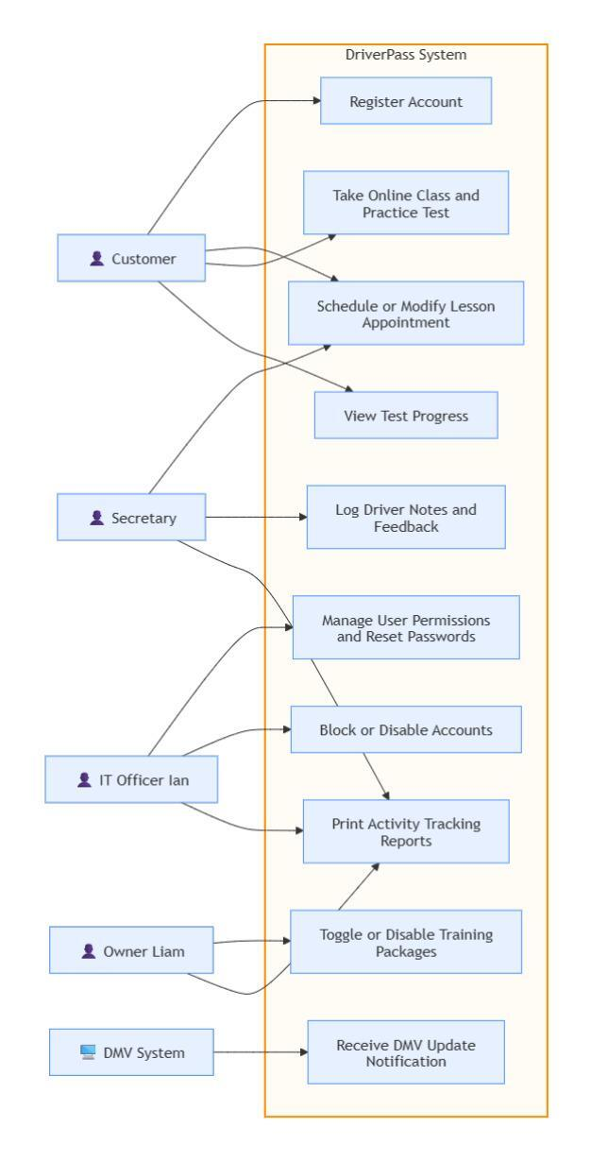

UML Activity Diagrams

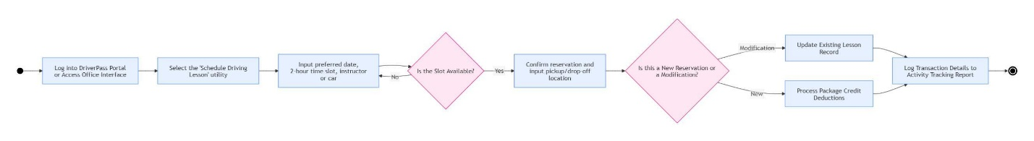

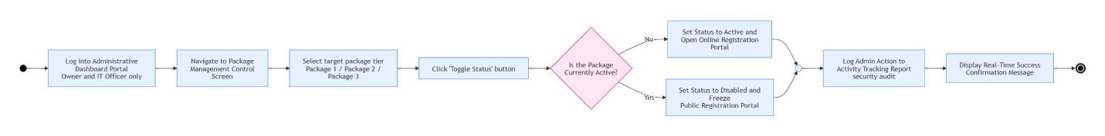

UML Sequence Diagram

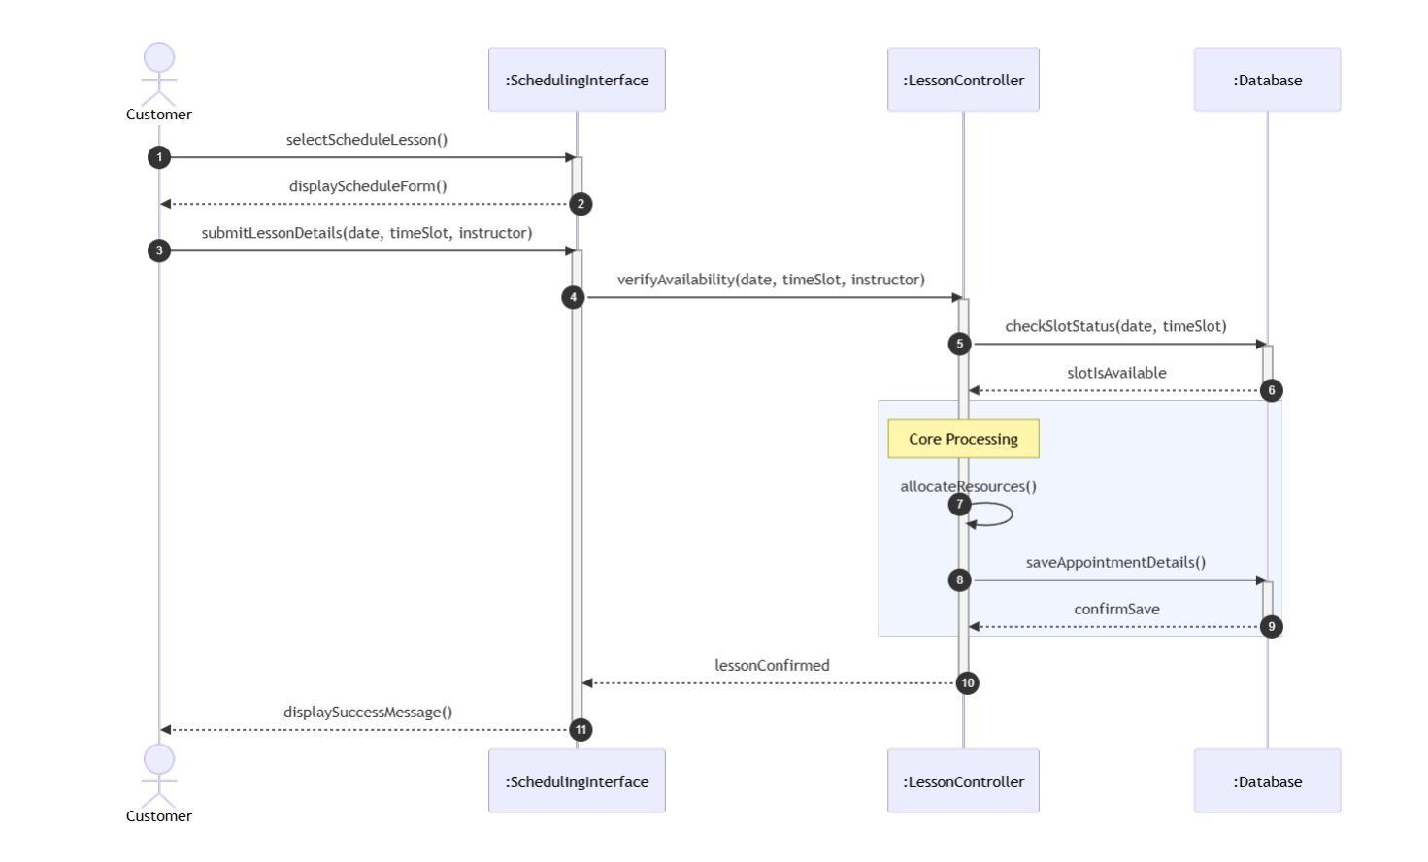

UML Class Diagram

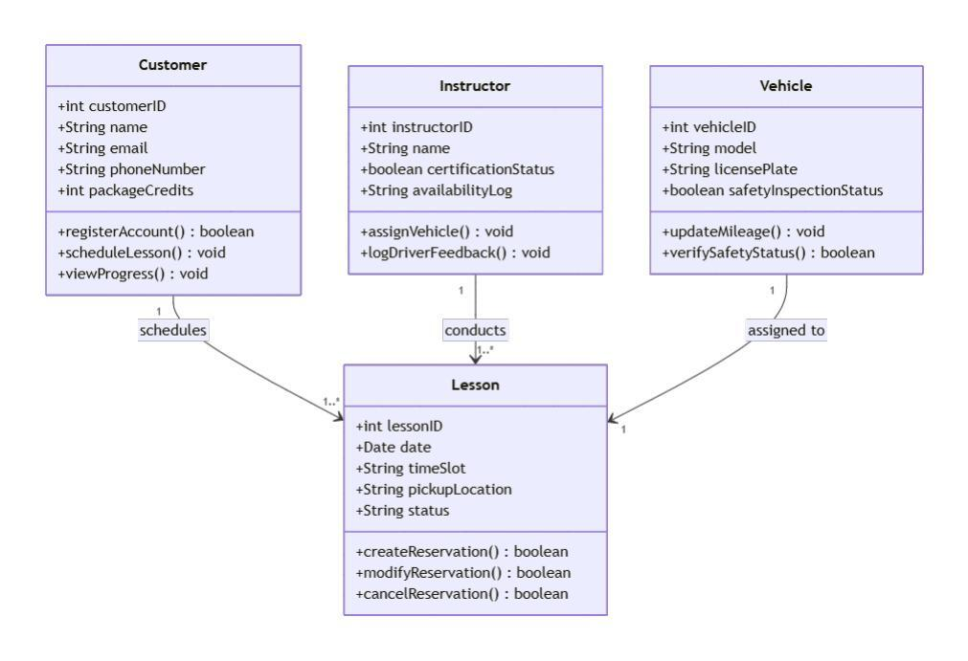

Technical Requirements

Hardware Requirements
The system must sustain simultaneous user access from customers, scheduling staff, administrative officers, and automated external background connections.

- Production Application & Database Servers (Cloud-based): * Compute: Virtualized multi-core processors (minimum 4 vCPUs) to handle concurrent traffic spikes during peak lesson booking hours.

  - Memory: Minimum 16 GB RAM to maintain active application memory pools, user session tokens, and caching layers for lesson schedules.

  - Storage: High-performance SSD storage (minimum 100 GB with auto-expanding logic) configured in a RAID-equivalent cloud environment to guarantee rapid read/write operations for transactional logging.

- End-User Access Hardware:

  - Client Devices: Standard computing endpoints (Laptops, Desktops, or Mobile Tablets) capable of running a modern web browser to display the responsive front-end portal interfaces.

Software Requirements
The software layers mirror the object models, methods, and controllers defined across the sequence and class architectures.

- Front-End Web Portal:

  - Languages & Frameworks: HTML5, CSS3, and JavaScript utilizing a responsive component framework (e.g., React, Angular, or Vue.js) to cleanly render interfaces such as the SchedulingInterface or the Administrative Dashboard.

- Back-End Application Logic:

  - Runtime Environment: An enterprise-grade, object-oriented ecosystem matching the design methods (e.g., Java with Spring Boot, C# with .NET Core, or Python with Django/FastAPI) to execute core business rules like verifyAvailability(), allocateResources(), and manage security state.

- Database Management System (DBMS):

  - Engine: A relational database system (e.g., PostgreSQL, MySQL, or Microsoft SQL Server) to enforce strict schema constraints for the structured entity classes (Customer, Instructor, Vehicle, Lesson) and ensure transactional consistency during concurrent booking requests.

Tools and Frameworks
These utilities accelerate development, secure administrative roles, and facilitate testing.

- Object-Relational Mapping (ORM): Libraries like Hibernate (Java) or SQLAlchemy (Python) to bind database tables directly to the system's class structures without manual SQL scripting.

- Identity and Access Management (IAM): Integration of secure authentication protocols (such as OAuth 2.0 or OpenID Connect) to isolate role-based features. This keeps the Administrative Dashboard locked exclusively to the Owner and IT Officer actors while managing separate access for Customers and Secretaries.

- Testing Suites: Integrated automated framework utilities (e.g., JUnit or PyTest) to constantly validate business logic parameters and resource constraints.

Infrastructure Requirements
The underlying environment must support seamless real-time notifications, external system data handshakes, and strict security auditing.

- Cloud Hosting Environment: High-availability cloud infrastructure (e.g., AWS, Microsoft Azure, or Google Cloud Platform) deploying multi-availability-zone load balancing to maximize application uptime.

- Integration Mechanisms (APIs): Secure RESTful or web hook API endpoints to support asynchronous data synchronization with external third-party entities, specifically satisfying the requirement to connect with the external DMV System node for updating statuses and processing confirmation alerts.

- Security & Audit Infrastructure:

  - Encryption: Enforced HTTPS network protocol using SSL/TLS certificates to protect all user data, passphrases, and lesson record transmissions over the web.

  - Audit Logging Layer: Dedicated central logging storage (such as the ELK Stack or cloud-native monitor logs) specifically designed to ingest and immutably record system telemetry from the backend controller, generating the mandatory Activity Tracking/Security Audit Reports whenever package tiers are toggled or user statuses change.

